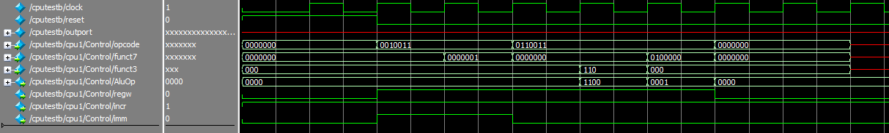

First waveform test of my cpu, shows that the opcode funct7 and funct3 are correctly taken from the instructions.

The hex file has been verified in external assemblers so its correct.

The full waveform on the next page shows the full functionality of the cpu.

It shows that the imem works correctly as opcode funct7 and funct3 are correct. ALUOp is also correct.

The ALU doesn’t function correctly, this may be due to the registers not working correctly.

Will try to reset the registers

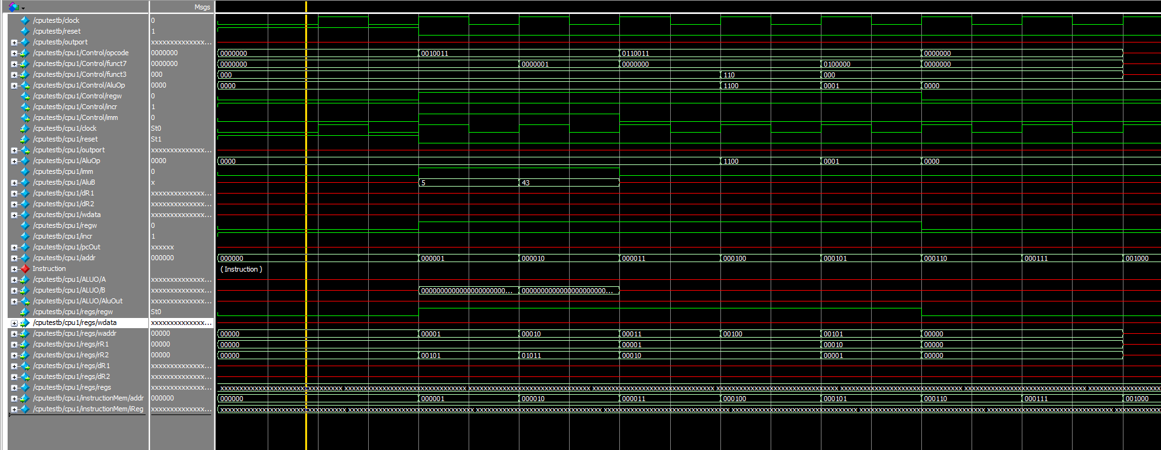

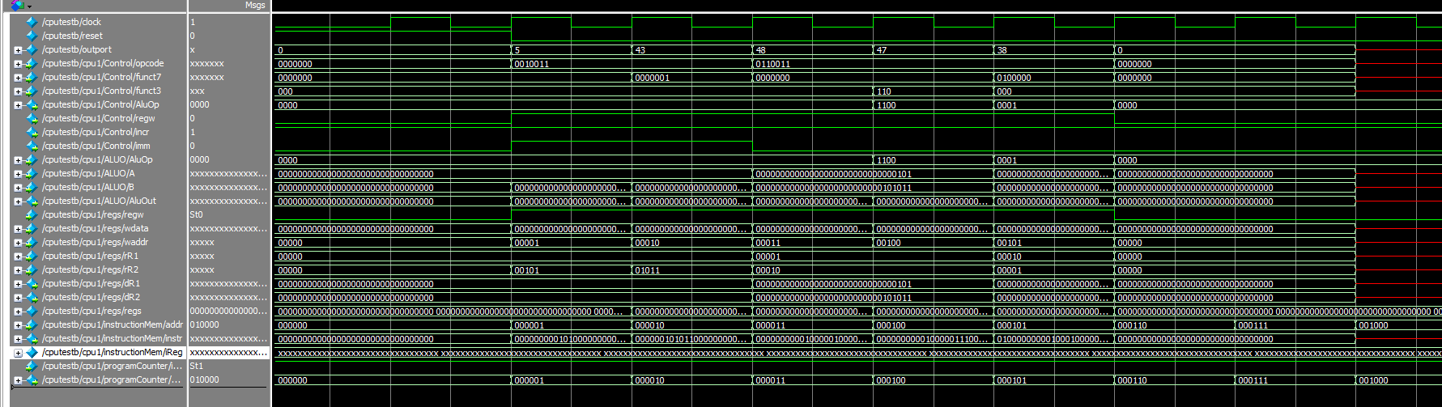

Version 1 complete!!!!!!!!!!!!!!!!